HACKMATRIX 2026 – ROUND 2
PROJECT DOCUMENTATION

Team Name : Assembly Coders
Team Leader : Shrikar Shelar
Contact : 7796386334

Team Members
- Mayur Kaithwas - 9175203369
- Harsh Shedge – 7517869068
- Sadhak Shinde – 8669079657

Project Name / Title
OptiTriage
The Edge Native Optical Triage Engine

GitHub Repository Link:
OptiTriage

Demo Video Link:

Problem Statement
Telemedicine provides convenient access to doctors, but remote consultations often lack objective physiological information such as heart rate and respiratory rate. Doctors may have to depend primarily on patient-reported symptoms and visual observation.
Similarly, in crowded emergency departments, manually collecting basic vital signs from every patient can increase triage time and make it difficult to quickly identify patients who may require urgent attention.
Existing monitoring solutions often depend on dedicated medical hardware, while cloud-based video processing can introduce additional privacy, bandwidth, and latency concerns.
OptiTriage addresses this gap by using a standard webcam to extract physiological signals locally and provide real-time, privacy-preserving triage information to healthcare providers.

Summary
OptiTriage is a browser-based, edge-native clinical triage prototype that uses a standard webcam and remote photoplethysmography (rPPG) to estimate physiological parameters including Heart Rate, Heart Rate Variability, and Respiratory Rate.
The system uses facial landmark detection to identify suitable facial regions, extracts RGB signals, and processes them using the CHROM algorithm and digital signal processing techniques.
A Signal Quality Indicator evaluates whether the extracted signal is sufficiently reliable. The resulting measurements are then evaluated using a NEWS2-based scoring approach to generate Red, Yellow, or Green triage priorities.
A major architectural feature is local processing. The patient's raw video remains on the local device, while only the derived physiological data and triage information are transmitted to the backend and displayed on the doctor's dashboard.

Problem Being Solved
OptiTriage focuses on four major challenges:
- Lack of objective vital signs in telemedicine
Doctors often do not have immediate access to physiological measurements during remote consultations.
- Slow initial triage
Manual collection of basic vital signs can increase assessment time in high-volume healthcare environments.
- Hardware dependency
Conventional physiological monitoring requires dedicated sensors or medical devices that may not always be available.
- Patient video privacy
Sending raw video to remote servers for analysis increases the amount of sensitive patient data being transmitted.
Our approach: Use an existing webcam as a contactless sensing device, process the video locally, extract physiological measurements, and transmit only the required health data for clinical triage.

Platform Preview
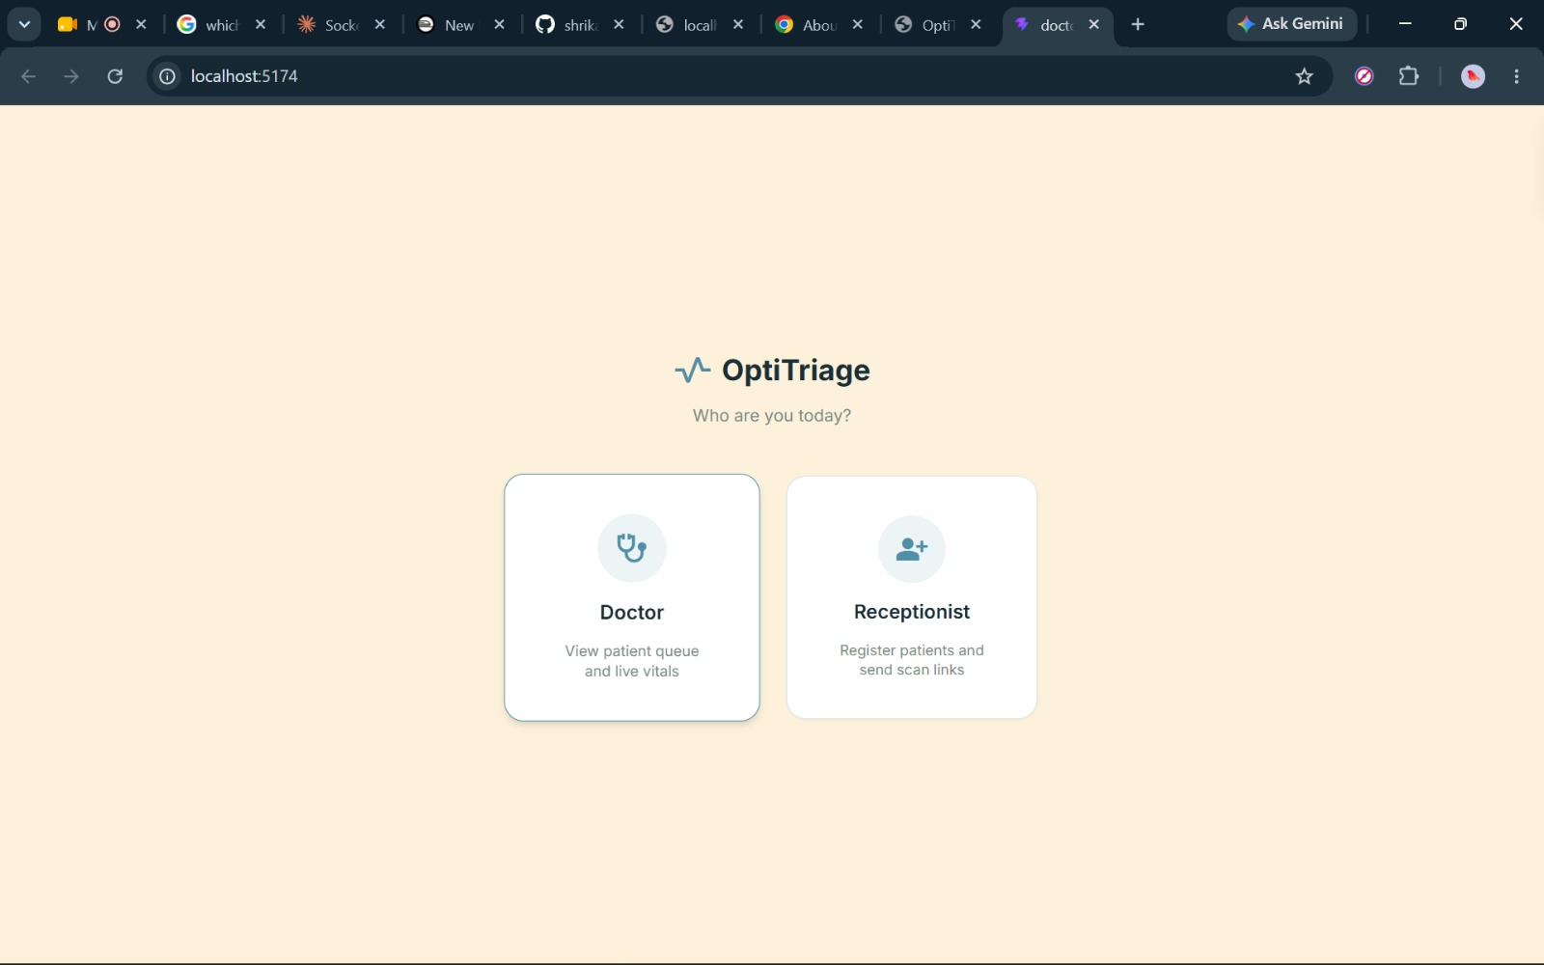
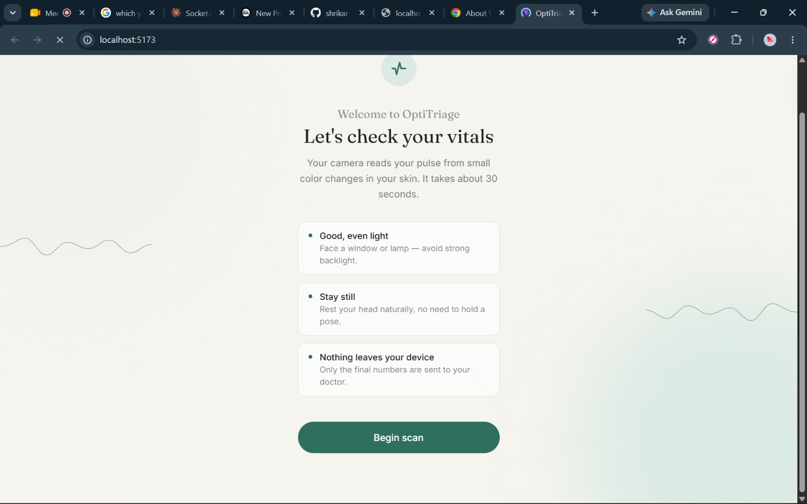
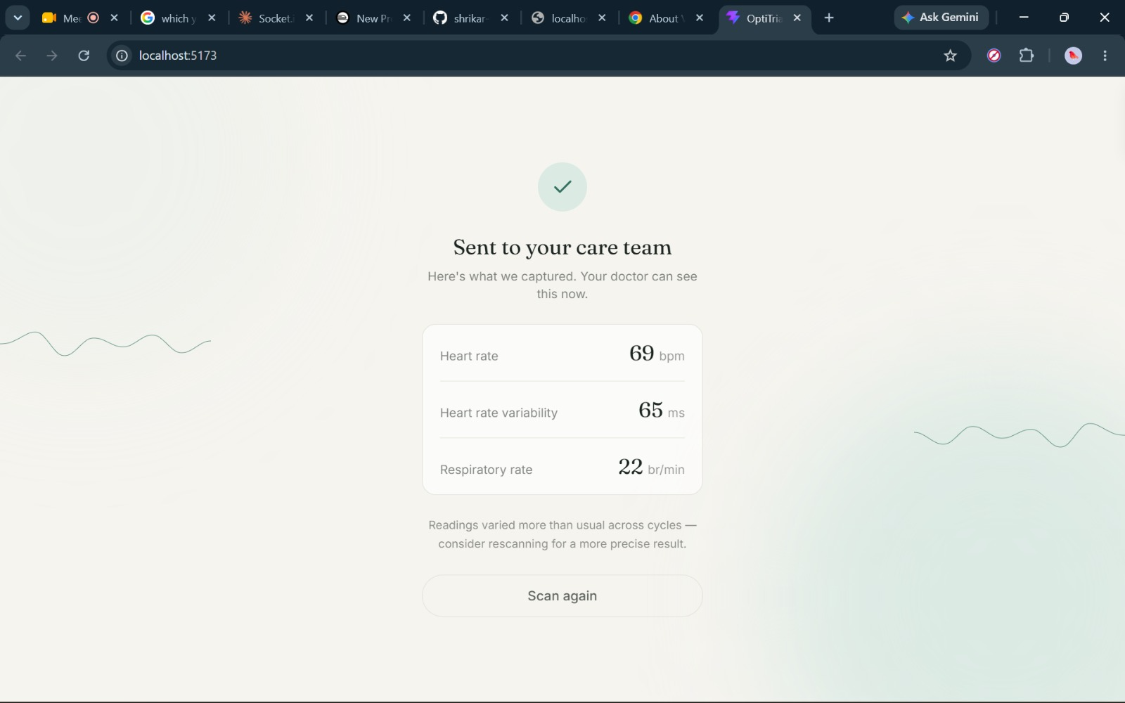

USP — Unique Selling Point
From Webcam-Based Measurement to Privacy-Preserving Clinical Triage
OptiTriage combines multiple components into a single browser-based workflow:
- Contactless rPPG monitoring using a standard webcam.
- Local edge processing so raw patient video does not need to leave the device.
- CHROM-based signal processing for extracting the physiological pulse signal.
- Signal Quality Indicator to identify unreliable measurements.
- NEWS2-based triage scoring to convert physiological measurements into Red, Yellow, and Green priorities.
- Real-time doctor dashboard for monitoring patient vitals and triage status.
Key USP: OptiTriage does not stop at measuring physiological parameters; it converts those measurements into real-time triage information while keeping raw video processing on the patient's device.

Key Features
1. Webcam-Based Vital Monitoring
Uses a standard browser webcam to estimate:
- Heart Rate
- Heart Rate Variability
- Respiratory Rate
2. Facial Landmark Detection
MediaPipe Face Mesh identifies facial landmarks and enables selection of appropriate forehead and cheek regions for signal extraction.
3. CHROM-Based rPPG
RGB signals extracted from facial regions are processed using the CHROM algorithm to isolate the physiological pulse signal.
4. DSP and FFT Analysis
Digital signal processing and Fast Fourier Transform analysis are used to identify the dominant pulse frequency and estimate heart rate.
5. Signal Quality Indicator
The system evaluates signal quality and identifies conditions such as excessive movement, poor positioning, or inadequate lighting that may affect measurements.
6. Edge-Native Processing
Video processing is performed locally using browser-based computing technologies rather than sending raw patient video to the backend.
7. Automated Triage
Vital measurements are evaluated using a NEWS2-based scoring approach to generate:
- Red — High Priority
- Yellow — Moderate Priority
- Green — Low Priority
8. Real-Time Doctor Dashboard
Doctors can view patient physiological measurements, triage status, and alerts through a centralized dashboard.
9. Real-Time Communication
WebSockets/Socket.io enable real-time transmission of processed patient data between the patient interface and doctor dashboard.
10. WhatsApp-Based Communication
whatsapp-web.js is used for WhatsApp-based patient communication and notification functionality.
11. Secure Data Storage
Supabase is used as the PostgreSQL-based backend database for storing relevant patient sessions, vital logs, and application data.

Future Scope
- Clinical Validation: Compare the system against medical-grade monitoring devices across diverse populations and real-world conditions.
- Additional Vital Parameters: Explore estimation of parameters such as SpO₂ and blood pressure after appropriate technical and clinical validation.
- AI-Based Risk Prediction: Extend the current rule-based triage system with machine-learning models for early deterioration prediction.
- EHR Integration: Integrate OptiTriage with Electronic Health Record systems and existing hospital workflows.
- Mobile Support: Extend the system to smartphones and tablets for broader accessibility.
- Longitudinal Monitoring: Store and analyze historical vital trends for continuous patient monitoring.
- Large-Scale Deployment: Adapt the system for emergency departments, telemedicine centers, and remote healthcare facilities.
- Regulatory and Clinical Readiness: Conduct formal clinical studies and pursue relevant healthcare and medical-device compliance requirements.

